Apache Kafka

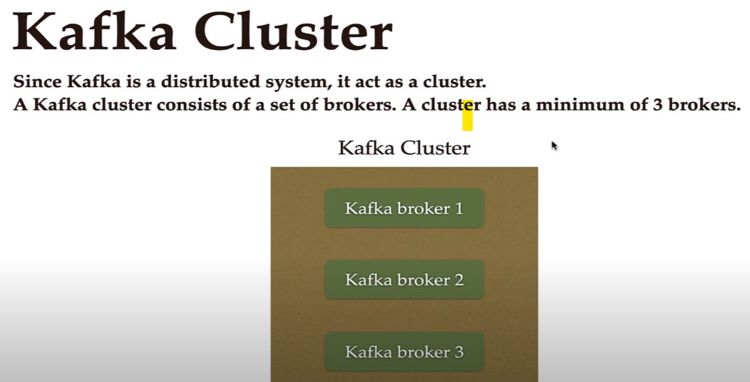

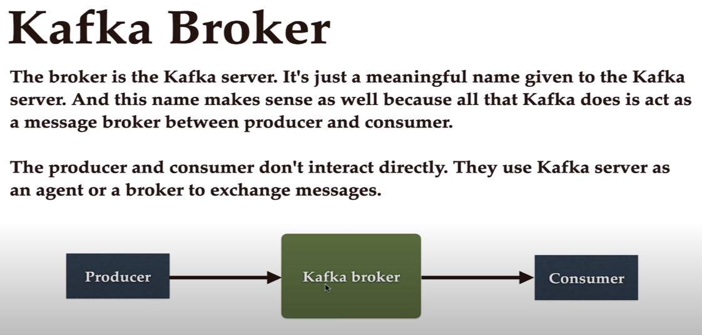

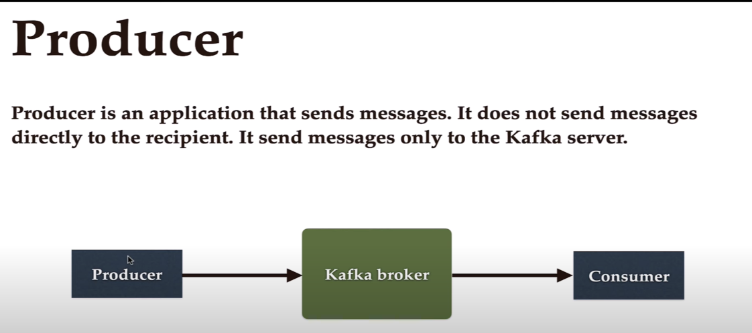

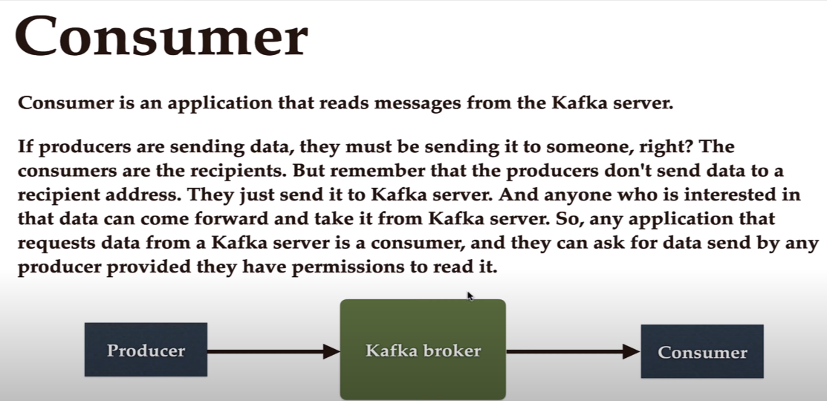

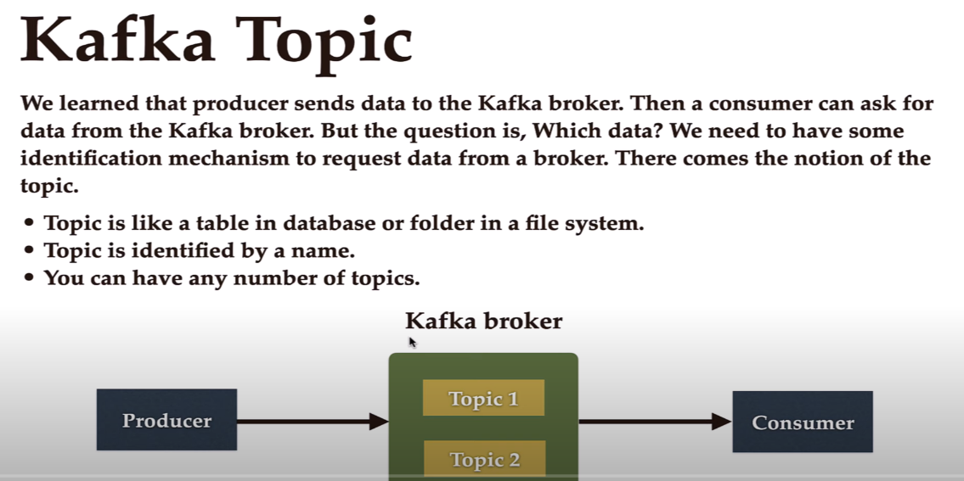

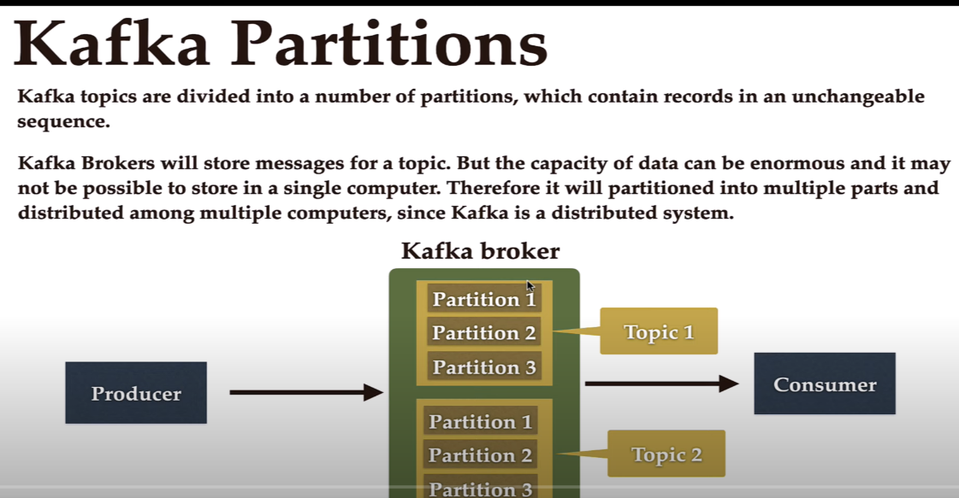

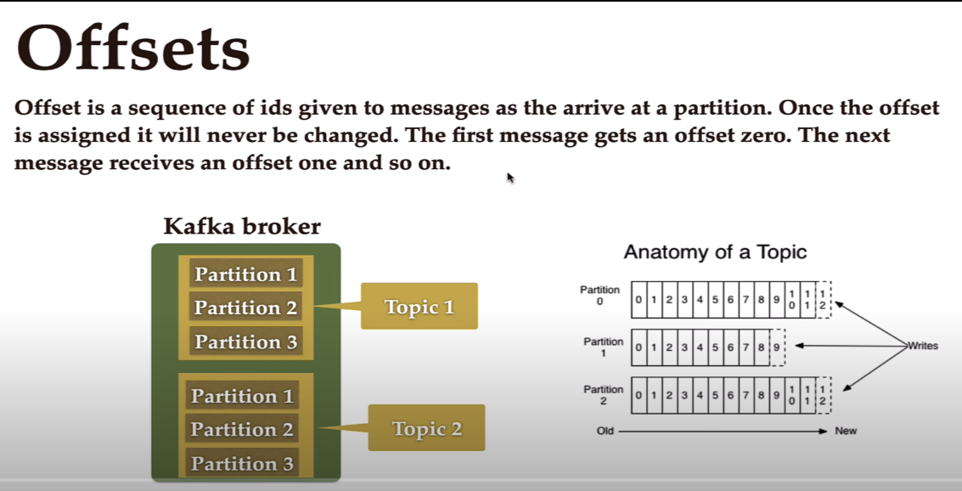

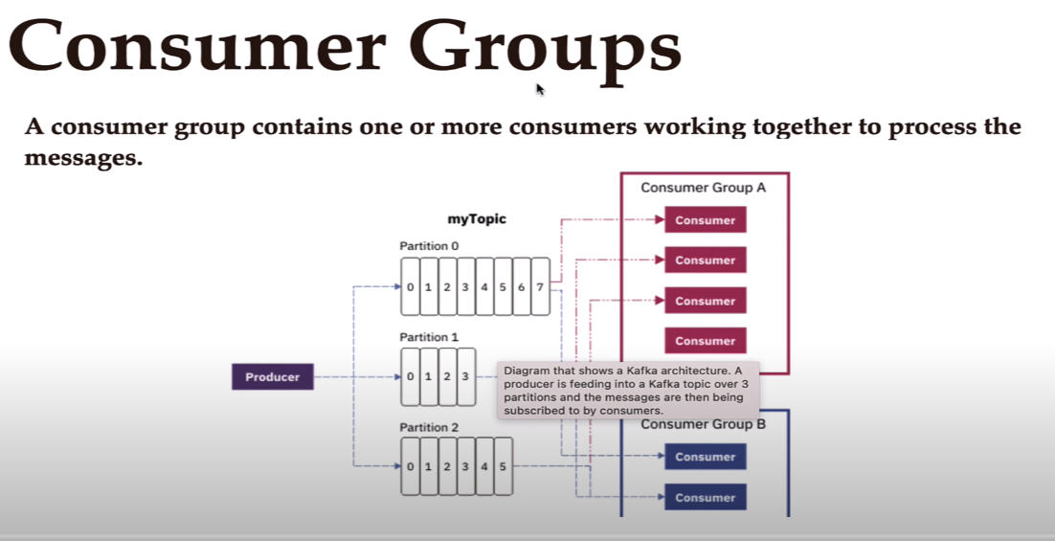

Use this page for installation of kafka
https://kafka.apache.org/quickstart

We make use of Kafka template present in spring.
In the context of Spring for Apache Kafka, KafkaTemplate is a high-level abstraction that simplifies the process of sending messages to Kafka topics, acting as a wrapper around the underlying Kafka producer and providing convenient methods for sending data. [1, 2, 3, 4]

Here's a more detailed explanation: [1, 4]
- Abstraction: KafkaTemplate hides the complexities of interacting with the low-level Kafka producer API. [1, 4]
- Convenience Methods: It provides methods for sending messages to Kafka topics, including methods for specifying the topic, key, partition, and timestamp. [2, 3]
- Producer Wrapper: KafkaTemplate wraps a Producer instance, which is thread-safe, allowing for efficient message sending. [5, 6]
- Spring Integration: It's part of the Spring for Apache Kafka project, which integrates core Spring concepts with Kafka-based messaging solutions. [7, 8]
- ProducerFactory: To create a KafkaTemplate, you need a ProducerFactory which instantiates the underlying Kafka producer. [1]
- Configuration: You can configure the KafkaTemplate with a simple map or automatic configuration based on property files. [1]
- Serialization: The KafkaTemplate handles the serialization of key and value pairs being transmitted. [4]
Example:

@Autowired
private KafkaTemplate<String, String> kafkaTemplate;
public void sendMessage(String topic, String key, String value) {
kafkaTemplate.send(topic, key, value);
}

